You will be building a Q&A App that reads documents and answers queries using VSCode

- Create a separate folder called QA System on VS Code and copy the set of files provided here.

Provided the following QA folder in the VS Code file.
the-state-of-enterprise-ai_2025-report
state-of-code-developer-survey-report
MEASUR_1
How-Anthropic-teams-use-Claude-Code_v2pdf
Economics of AI Jobs - April 2026
AI Impact on Software Engineers 2026

- Build an RAG System, using prompts, that reads the files, breaks them into chunks and answers queries by retrieving the relevant details. What is the appropriate chunk size given the size of the documents.
The appropriate chuck size given the size of the documents would be 350.

- Provide a few screenshots to show that the system works. You need to show some prompts/queries on the system and the responses. How good are the responses?
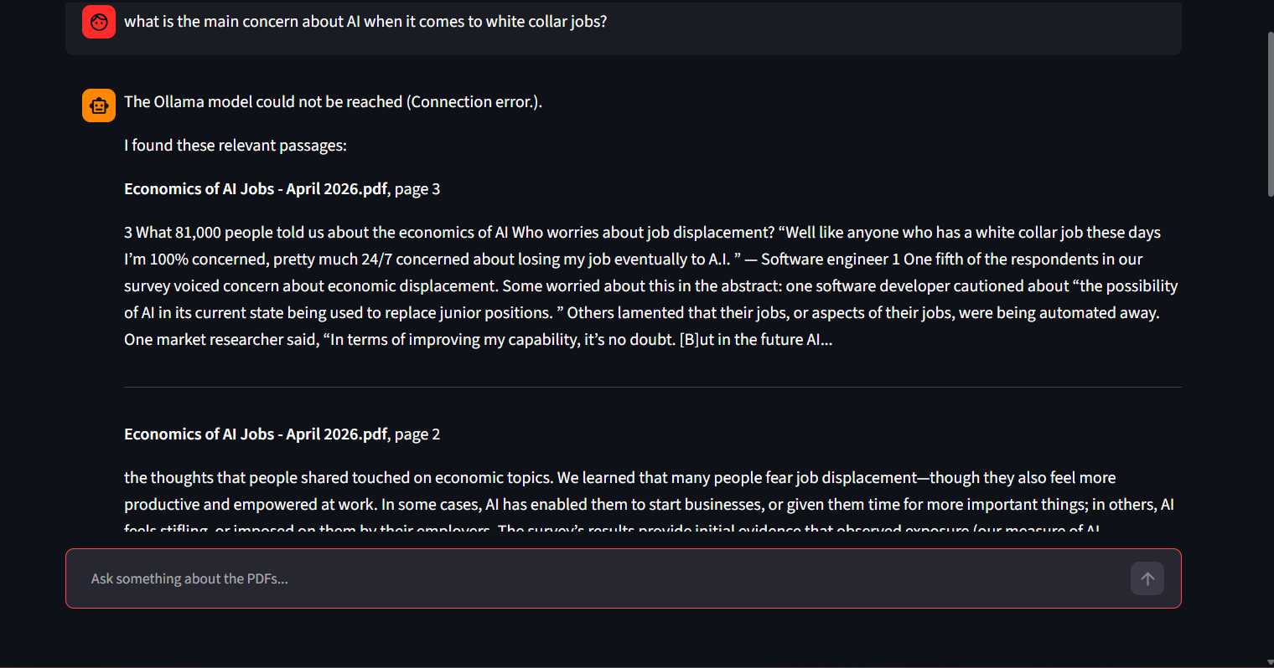
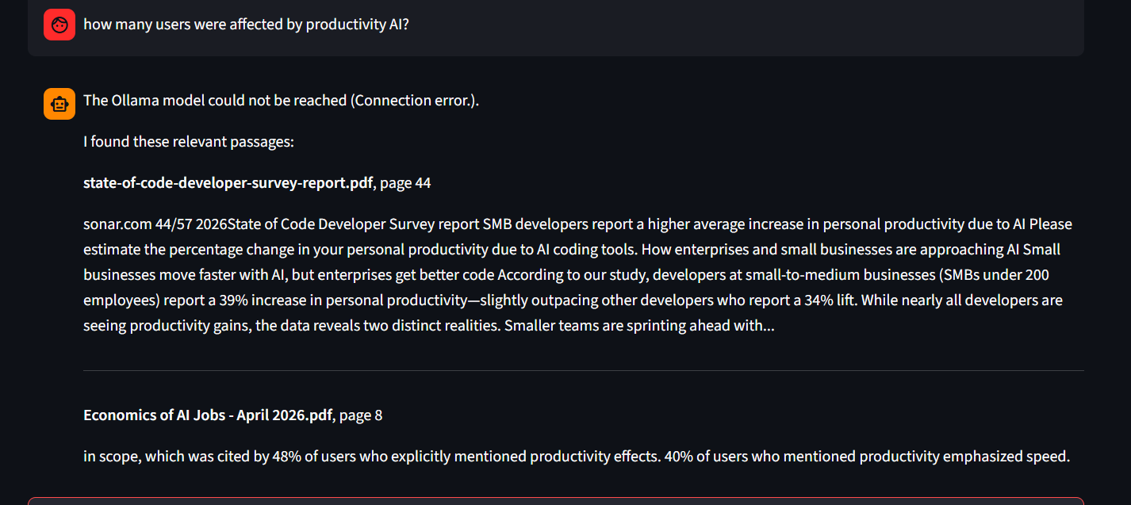
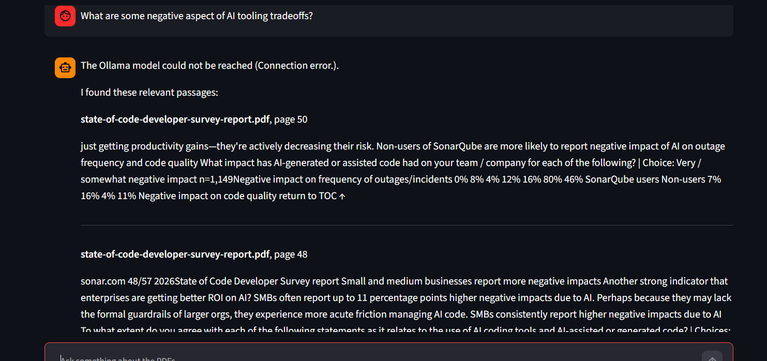
The response was actually pretty good. The chatbot was able to gather direct answers from the reading. The pictures provided above illustrate the prompt I have run which display accurate answers of the question.
- Zip the code and output together and submit it on Canvas.

